# Introduction

GNSS provides a platform that can and has been used to provide continuous on board orbit determination, attitude determination, and positioning for spacecraft in low Earth orbit, and has been used above the GPS constellation [3]. This provides a layer of autonomy for spacecraft, and reduces cost that would be associated with ground tracking of the spacecraft. This is appealing to a lunar mission which need the improved accuracy in position and velocity estimates, while reducing mission costs. Lunar missions bring about many new challenges for GNSS positioning, including weak signals and poor satellite geometry [3,4,5,]. GNSS receivers capable of acquiring these weak signals are being developed, and solutions using new navigation constellations near the Moon, or adaptive filters to deal with the poor geometry [1], have been proposed.

# Lunar Mission Phases

Lunar exploration missions can be split into parts, or mission phases. These phases are split based off of their characteristics such as dynamics, distance, and mission requirements. Each phase has unique challenges associated with it. These phases were identified for ESA Moon-GNSS project, for both the European Student Moon Orbiter (ESMO), and the ESA Lunar Lander. ESMO was a proposed small satellite that would use a low thrust propulsion to take student payloads to lunar orbit. The lunar lander mission is a proposed to demonstrate precise autonomous planetary landing capabilities. Manzano [4] breaks the mission down into 8 phases. For this paper, the phases will be grouped under lunar transfer orbit, and lunar altitude, which includes LLO and surface operations.

## Lunar Transfer Orbit (LTO)

Lunar transfer orbit is the first phase for every lunar mission. It is the trajectory from LEO to the Moon’s sphere of influence. There are a few different Lunar transfer orbits, some of which are direct transfers, continuous spiral [3], and phasing loops. LTO can be further split into two parts: GTO like and outside the GPS constellation [3]. GTO or geostationary transfer orbit like, is the portion of LTO from LEO to geostationary orbit (GEO) altitudes. GNSS has been used extensively in this region, as much of the region is within the GPS constellation. Multiple studies have shown the feasibility of using GNSS above the constellation, and it has been used on a few spacecraft such as the Equatior-S mission, and the AMSAT Oscar-40 spacecraft [3,10]. Once outside the GPS constellation signals to noise ratios get lower, and geometry gets worse, increasing GDOP. As distance from the GPS constellation increases, occultation from the Earth increases, and the spacecraft must rely on the second and third lobes from the GPS Satellites. According to Carpenter[2], during LTO there are typically 2 or more GPS satellites in view out to about 18 Earth radii, after which it is rarely more than 2, and never more than 3 satellites. These effects and the challenges they bring are discussed further later on.

## Lunar Altitude

Lunar altitude includes all orbits inside the Moon’s sphere of influence, the descent/landing and surface operations on the Moon, as well as the Earth-Moon Lagrange points. Distance aside, use of GNSS at Lunar altitude can face interference from Lunar occultation [4].

# Challenges of GNSS for Lunar Missions

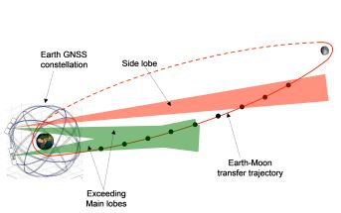

Figure :Visibility of lobes out of Earth Umbra [4]

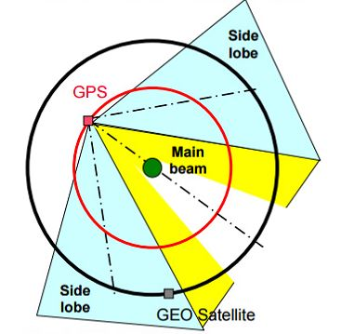

Figure : GPS signal lobes out to GEO, wih Earth occultation [10]

For GNSS to be useable during a Lunar mission, poor satellite geometry, occultation from the Earth and Moon, and weak signal strength must be overcome. Figures 1 and 2 above, show examples of how signals spread from the GPS satellites out past the constellation. The Earth blocks a large portion of the main lobe, requiring use of the weaker side(secondary) lobes of the GPS signal when on a LTO. Palmerini [5] shows the consequence of this poor geometry in figure 3, that plots GDOP across the distance from Earth’s surface to Lunar altitude.

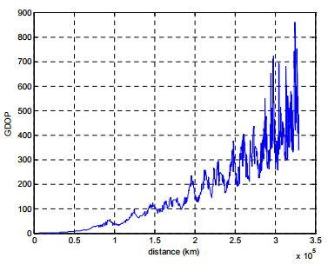

Figure :GDOP from Earth to Lunar altitude [5]

In a signal availability study done by Carpenter [2], the change in signal strength and satellite availability over a 3.5-day transfer to Lunar orbit, is observed for receivers with 3 different sensitivities using only L1 C/A code. The three sensitivities chosen are 25 dBHz (Navigator [6,7]), 18 dBHz (just beyond state of the art to decode), and 11 dBHz (just beyond state of the art to acquire). The baseline case is the 25dBHz receiver, which has an approximate minimum receiver power of -174 dBW, with a 10 dB antenna.

* Signal to noise ratios
  + Sats visibile due to signal strength
  + Values typical at various altitudes

# Receivers for Lunar Missions

* C/N0 thresholds,
  + what currently can be handled,
  + results from theoreticals
* Weak signals and receivers
* Snapshot receivers
  + architecture
  + Software Receivers
  + FFT/doubleFFT
  + FPGA
* Navigator receiver(GSFC)
* MosaicGNSS
* Antennas
* MoonGNSS/lunar navigation constellations
* Requirements of clock
* Proof of Concept tests

# Navigation Filters

* Aide from data-relay systems or ground tracking
  + Uploading of nav message not from gps signal
* Inclusion of spacecraft model(dynamics, kinematics, orbit, etc)
* Coupling of GNSS with other sensors
  + Sensors used during various phases of mission
  + Trade offs between performance and complexity
* Adaptive filters
* Estimation of Doppler shift/rate from position and velocity estimation

# Conclusions

* Best results in LTO
  + Important for correction burns
* Potential to reduce costs
  + Increased autonomy
  + Less ground tracking

# References

1. Capuano, Vincenzo, et al. "GNSS-based Orbital Filter for Earth Moon Transfer Orbits." *Journal of Navigation* 69.04 (2016): 745-764.
2. Carpenter, J. Russell, et al. "Libration point navigation concepts supporting the vision for space exploration." (2004): 16-19.
3. Palmerini, Giovanni B., Marco Sabatini, and Giorgio Perrotta. "En route to the Moon using GNSS signals." *Acta Astronautica* 64.4 (2009): 467-483.
4. Manzano-Jurado, María, et al. "Use of weak GNSS signals in a mission to the moon." *2014 7th ESA Workshop on Satellite Navigation Technologies and European Workshop on GNSS Signals and Signal Processing (NAVITEC)*. IEEE, 2014.
5. Palmerini, Giovanni B. "Assisted GNSS navigation in lunar missions." *AIAA space and astronautics forum and exposition*. 2014.
6. Bamford, William A., et al. "A GPS receiver for lunar missions." (2008).
7. Winternitz, Luke, et al. "Navigator GPS receiver for fast acquisition and weak signal space applications." (2004).
8. Montenbruck, Oliver, and Remco Kroes. "In-flight performance analysis of the CHAMP BlackJack GPS Receiver." *GPS solutions* 7.2 (2003): 74-86.
9. Esterhuizen, Stephan, et al. "TriG-A GNSS Precise Orbit and Radio Occultation Space Receiver." (2009): 1442-1446.
10. Ruiz, Jennifer L., and Charles H. Frey. "Geosynchronous satellite use of GPS." *Proceedings of ION GNSS*. 2005.
11. Balbach, Oliver, et al. "Tracking GPS above GPS satellite altitude: First results of the GPS experiment on the HEO mission Equator-S." *Position Location and Navigation Symposium, IEEE 1998*. IEEE, 1998.
12. Chao, C. C., and H. Bernstein. "Onboard stationkeeping of geosynchronous satellite using a global positioning system receiver." *Journal of Guidance, Control, and Dynamics* 17.4 (1994): 778-786.
13. Davis, George, et al. "GPS-based navigation and orbit determination for the AMSAT AO-40 satellite." *Proceedings of AIAA Guidance, Navigation, and Control Conference and Exhibition*. 2002.
14. Qiao, Li, L. Samsung, and R. Chris. "A multiple GNSS-based orbit determination algorithm for geostationary satellites." *IGNSS Symposium*. 2009.
15. Fisackerly, Richard, et al. "The ESA Lunar Lander Mission." *AIAA SPACE 2011 Conference & Exposition*. 2011.
16. Walker, Roger, and M. Cross. "The European Student Moon Orbiter (ESMO): A lunar mission for education, outreach and science." *Acta Astronautica*66.7 (2010): 1177-1188.